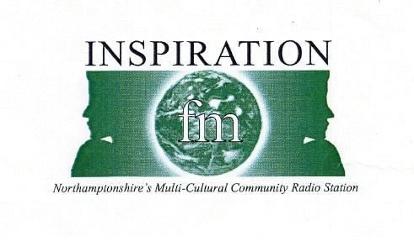

INSPIRATION FM Multi-Media Training Courses

APPLICATION FORM

FOR ADULTS

When completed this form should be forwarded to Jenny Campbell, Inspiration FM, 20 Sheep, Northampton. NN1 2LU. Tel: 01604 250544 Fax: 01604 250573 email: info@inspirationfm.com

PLEASE USE ONE APPLICATION FOR EACH PERSON APPLYING

Name of Course/Workshop: ______________________________________________________________

Day of Course: ______________________________________________________________

Time of Course: _______________________________________________________

APPLICANT DETAILS

Forename: ___________________________________ Surname: ___________________________________

Address:_____________________________________ Home Tel No.: ______________________________

_____________________________________________ Mobile No.: _________________________________

_____________________________________________ Date of Birth: _____________ Age: ____________

Post Code: _______________ Email: ______________________________________

EMERGENCY CONTACT DETAILS

Parents/Guardian: Title: _________ Initial: _________ Surname:____________________________

Daytime No._____________________ Evening No.______________________ Mobile No._____________________

Type of music you listen to (circle choice)
Rap / R&B / Dance / Reggae / Garage / Indie / Rock / Other (specify)
……………………………………………………………………………………………………………………………………………………..

Any Personal Goals (what do you want to achieve or develop from our course)
……………………………………………………………………………………………………………………………………………………..

GENDER: ◻ Male  ◻ Female | AGE: ◻ 19-21 ◻ 25+  ◻ 21-25

In order to help us measure whether our Equal Opportunities targets are being met, please complete questions below (please )

ETHNIC ORIGIN

◻ British | ◻ Chinese | ◻ Black African
◻ Black Caribbean | ◻ Pakistani | ◻ Bangladeshi
◻ White and Black African | ◻ White and Asian | ◻ Other Black
◻ Other White | ◻ India | ◻ Other Mixed
◻ White and Black Caribbean | ◻ Irish | ◻ Other Asian
◻ Other ethnic (please specify)
……………………………………………………………………
FOR INSPIRATION FM USE ONLY

Date received: Place Booked: Student Informed:

For Inspiration FM use only

Date received _____________ Place Booked ______________ Student informed ______________

